H2 Geography Preliminary Examination 2024
Marking Guide

Cluster 4 Fieldwork

1 | (a) | Explain whether the research question is appropriate for the investigation.  ‘How effective has the promotion of cycling been in changing commuting habits in Ang Mo Kio Town?’  Award 1 mark for each explanation of why research question is appropriate or not so appropriate.  Award a maximum of 1 additional mark for further development of each explanation, where applicable.  Award a maximum of 2 marks for explanation of either strength or weakness only.  Possible responses include:  - Strengths  - It is at a suitable scale as the investigation is confined within Ang Mo Kio. [1] The scale of investigation is suitable to 10 students. [1 additional mark]  - It is researchable because it is possible for students to collect the required data about the residents’ perception through survey. [1]  - Limitations  - The terms ‘how effective’ are subjective terms. [1] The understanding of these terms can be interpreted differently by different respondents. [1 additional mark]  - The research question did not specify the target audience, which failed to make the investigation less focused. [1] | [4]
 | (b) | Using Resources 1A and 1B, suggest why site 1 might be a better location than the other sites for the students to conduct the survey.  Award 1 mark for each explanation of why site 1 might be a better location, to a maximum of 5 marks.  Award a maximum of 1 additional mark for further development of each explanation, where applicable.  Award 1 mark of each explanation of the limitation of other sites, to a maximum of 2 marks.  Possible responses include:  - As seen in Resource 1B, Site 1 is a ‘multi-functional site’ with many services that cater to a diverse and large number of people. [1] As seen in Resource 1A, Site 1 is also near a MRT station. This will provide a wider range of respondents who possibly use different modes of transportation and able to survey beyond those who only commute by bicycles. [1 additional mark]  - Site 1 is next to a cycling path and bus interchange, and there would be commuters who can provide more accurate perception on how the provision of cycling paths have changed their commuting habits such as cycling from bus interchange to their homes. [1]  - Site 1 is adjacent to a cycle path and so more cyclists would be available for the survey. [1]  - Site 3 was at the end of a small road and the foot traffic might be lower. [1]  - Site 4 was at the entrance of a large carpark that is likely frequented by car users rather than those who cycle. [1] This would limit the relevance of the responses, as the participants may not have substantial experience or opinions on cycling or other mode of transportation such as public transport. [1 additional mark] | [5]
 | (c) | With reference to Resources 1A and 2, explain how the students can best conduct their survey.  Award 1 mark for each explanation on how to best conduct the survey.  Award a maximum of 1 additional mark for further development of each explanation, where applicable.  Possible responses include:  - The students should split into 5 groups of 2 as there are ten of them. And at each site, survey 20 respondents in one day. [1]  - They should conduct the surveys at specific timings, e.g. from 8-10am and 5-7pm as these are the peak hours when people are commuting to and from work. [1] Surveys to be conducted simultaneously at different sites as seen in Resource 1A, enhancing efficiency. [1]  - When choosing the survey respondents, the students can consider stratified random sampling method. It is an effective method to ensure that different segments of the population are adequately represented in the survey. [1]  - They can identify respondents based on key demographics (age, gender, etc) and aim to survey a balanced mix within these categories. [1 additional mark]  - They can also identify the possible respondents based on how they commute public transport users, cyclists and shoppers. [1]  - The students are to ensure that each strata have an equal quota at each site. This helps to ensure a representative sample to represent each strata fairly. [1]  - As students conduct the survey, they should record each respondent’s information on the tracking sheet. [1]  - Mark each respondent according to their commuter type and demographic information and keep track of the numbers in each strata. [1] And use Day 2 of their investigation to ensure the quota is met. [1 additional mark]  - They should position themselves at a spot where they do not obstruct the residents who are walking along the pathways as seen in Resource 2. They can stand under the sheltered walkways leading to the bus stop. [1] | [6]
 | (d) | With reference to Resource 2, suggest how the students can minimise the impact of their investigation.  Award 1 mark for each explanation on how the students could minimise the impact of their investigation, to a maximum of 5 marks.  Award a maximum of 1 additional mark for further development of each explanation, where applicable.  Possible responses include:  • Students could ensure that they collect all litter and fieldwork materials at all the five sites before leaving to avoid polluting the area [1 mark].  • Students could avoid disturbance to urban wildlife / the residents living nearby by keeping noise to a minimum. [1 mark].  Students should avoid crowding at the various sites to prevent obstructing residents in the area. [1] As shown in Resource 2, there is a cycling path and pedestrian walkway beside the bus stop, which could become potentially get crowded therefore, students should conduct the survey away from the middle of the paths and move to the side. [1 additional mark]  • Students should avoid trampling or disturbing the bushes, as shown in Resource 2, while conducting the survey to minimise the environmental impact on the surroundings. [1] | [5]
 | (e) | Construct a suitable data representation method for the results shown in Resource 4.  Award maximum 4 marks for drawing of a suitable data representation method.  Award 1 mark each for;  - Title  - Axis  - Legend/Labelling of each bar graph  - Proportions of bar graphs  Title: Selected results from the survey for Questions 3,12,14  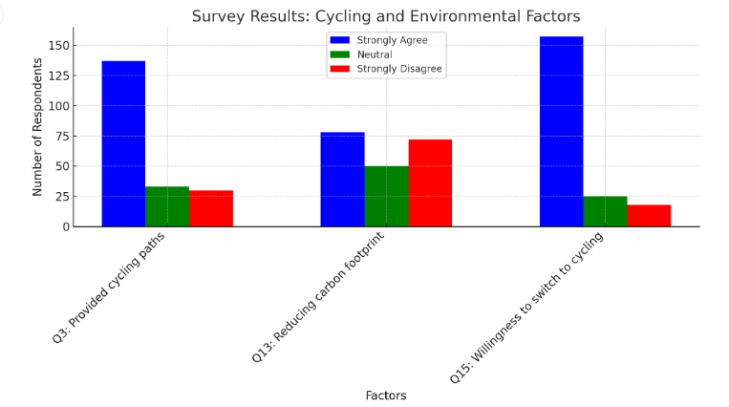 | [4]
 | (f) | Explain the strengths and weaknesses of the questionnaire shown in Resource 3.  Award 1 mark for each explanation of a strength or a weakness.  Award a maximum of 1 additional mark for further development of each explanation. Award a maximum of 3 marks for explanation of either strengths or weaknesses only.  Possible responses include:  Strength  - The sensitivity of the request for age group of below 15, 15-64 and 65 and above, rather than specific age of participants [1] which respondents may not want to divulge and may also be easier in capturing the opinions of different groups [1 additional mark]  - The simplicity of the tick box format which makes it easy for the respondents to fill it out. [1]  - The questions are relevant and cover a wide range of aspects covered by the five categories of ‘cycling infrastructure’, ‘safety’, ‘cost, ‘time’, ‘user-friendliness’ and ‘eco-friendliness’. [1] They cover very specifically a range of factors to assess cycling. [1 additional mark]  Weakness  - There is an overly broad categories of 15 to 64 age group that includes teenagers, young adults, middle-aged adults and those nearing retirement.[1] Each of these sub-groups may have vastly different experiences, needs and perceptions of cycling. Grouping them together can mask important differences in survey results. [1 additional mark]  - Respondents under 15 category might include children who do not make independent transport decisions. [1] And their responses can skew results and might not provide meaningful data on commuting preferences on cycling. [1 additional mark]  - Having only three response options of ‘strongly agree’, ‘neutral’ and ‘strongly disagree’ will result in limited spectrum of opinions. [1] This could lead to misleading conclusions about the intensity of respondents’ opinions. [1 additional mark]  - The survey options also forces the respondents into making extreme choices of strongly agree or disagree and increase the likelihood of neutral responses. [1] This can affect the accuracy of the results collected. | [6]
 | (g) | Using all the resources, evaluate the accuracy and reliability of the data collected.  Possible Approaches include:  Candidates could evaluate the investigation by reviewing the methods used to collect data and the data collected in Resource 4. Candidates could review the data collection method, the questionnaire used, and assess the impact on accuracy and reliability of data collected. Evaluation of these methods could include looking at the sample size, whether the samples selected are representative of the resident population in Ang Mo Kio, the range of five different sites as seen in Resources 1 and 2, strengths and weaknesses of the different methods, etc.  Candidates could consider the clarity of the terms used in the questionnaire survey seen in Resource 3 and how these could give rise to differing interpretations by the residents. For instance, to some residents, the feeling of being safe using the cycling path could mean concerns about collisions with other cyclists, pedestrians. It could also mean the condition of the cycling path, such as lighting or surface quality. Candidates could consider how such differing interpretations could affect the conclusions that could be drawn from the analysis of these data in addressing the research question, was well as the accompanying reasons why it may be valid/invalid.  Levels marked using Generic Level Descriptors for H2 fieldwork evaluative questions.  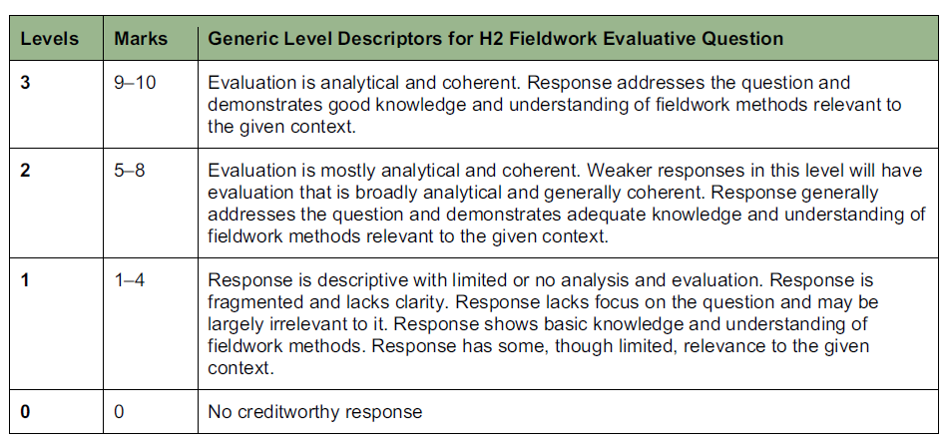 | [10]

Cluster 3 Sustainable Future and Climate Change
2 | Resource 5 shows the changes in mean temperature in UK. Resource 6 shows UK’s changes in energy use over time. Resource 7 shows the annual percentage change in global CO2 emissions in 2022.
 | (a) | Describe one natural factor that influences temperature variability in the Quaternary period.  Award 1 mark for a description of a natural factor.  Award 1 additional mark for further development of each description, where applicable,  Possible responses:  - Milankovitch Cycles  - Orbital Eccentricity: The shape of Earth's orbit around the Sun changes from more circular to more elliptical over approximately 100,000 years.[1 mark] This affects the distance between Earth and the Sun, influencing the amount of solar energy Earth receives, thereby impacting temperature variability where a more elliptical orbit results in cooler climates.[1 additional mark]  - Axial Tilt (Obliquity): The angle of Earth's axis relative to its orbital plane varies between 22.1° and 24.5° over a 41,000-year cycle [1 mark]. Changes in axial tilt influence the severity of seasons, affecting temperature patterns and contributing to glacial and interglacial periods.[1 additional mark]  - Thermohaline circulation  - Thermohaline circulation is driven by differences in water density, which are controlled by temperature and salinity. [1 mark] Colder, saltier water is denser and sinks, while warmer, less salty water rises and this movement influences heat distribution across the planet.[1 additional mark]  - Formation of ice sheets during the glacial period or melting of ice sheets during the interglacial period affects the salinity of oceans.[1 mark] This can affect the strength of the thermohaline circulation which in turn contributes to temperature variability [1 additional mark] |  | [4]
 | (b) | Describe the changes in mean temperature in UK as shown in Resource 5.  Award 1 mark for a description.  Award 1 additional mark for further development of each description, where applicable,  Possible responses:  - Throughout the entire period, the graph shows considerable year-to-year fluctuations in mean temperature. [1 mark]  - These fluctuations are particularly pronounced in the early to mid-20th century. [1 mark]  - Overall there has been an increase in temperature from 8.5 ºC in 1884 to 9.6 ºC in 2020 [1 mark]  - The lowest temperature recorded was 7 ºC in late 19th century whilst the highest temperature was 9.9 ºC in early 21st century (2015) [1 mark]  - There is a significant increase in mean temperature from the 1980s onwards, especially in the 21st century. [1 mark] |  | [4]
 | (c) | Explain how these changes as shown in Resource 5 can impact on aquatic and terrestrial ecosystems.  Award 1 mark for each explanation.  Award 1 additional mark for further development of each explanation, where applicable.  Award a maximum of 3 marks for an explanation of either aquatic or terrestrial ecosystems only.  Possible responses:  Aquatic ecosystems:  - Temperature Sensitivity: Aquatic organisms are often highly sensitive to temperature changes as temperature has increased by 3ºC over the century [1 mark] Increased temperatures can disrupt metabolic rates, reproductive cycles, and survival rates of many species.[1 additional mark]  - Oxygen Levels: Warmer water holds less dissolved oxygen, stressing or killing fish and other aquatic life.[1 mark]  - Algal Blooms: Higher temperatures can promote the growth of harmful algal blooms. [1 mark] These blooms can produce toxins that are harmful to aquatic life and can lead to dead zones where most marine life cannot survive. [1 additional mark]  - Migration Patterns: Fish and other marine species may shift their ranges northward or to deeper, cooler waters, disrupting existing ecosystems and potentially leading to a loss of biodiversity.[1 mark]  - Coral Reefs: Increased sea temperatures can cause coral bleaching,[1 mark] where corals expel the algae (zooxanthellae) that live in their tissues, leading to the coral’s death if stressful conditions persist.[1 additional mark]  Terrestrial ecosystems:  - Species Distribution: Many terrestrial species may shift their ranges toward the poles or to higher altitudes in response to warming temperatures, leading to changes in ecosystems [1 mark]  - Habitat Loss: Increased temperatures can lead to habitat loss as species adapted to cold climates may find their habitats shrinking.[1 mark]  - Forest Health: Warmer temperatures can stress forests, making them more susceptible to pests, diseases, and wildfires. [1 mark] This can result in a loss of forest cover and biodiversity.[1 additional mark] |  | [6]
 | (d) | Using Resource 6, describe the changes in UK’s energy consumption.  Award 1 mark for each explanation.  Award 1 additional mark for further development of each explanation, where applicable.  Possible responses:  - Total energy consumption in the UK has decreased from around 1995 to 2020. [1 mark] Around 1995, the total consumption was approximately 230 million tonnes of oil equivalent, but this has reduced to approximately 160 million tonnes by 2022[1 additional mark]  - Bioenergy has seen the most significant increase from negligible amounts prior to 2000 to 20 million tonnes by 2020 [1 mark]  - All the fossil fuels (coal, gas, oil) have seen a decline whilst there has been an increase for renewable energy of bioenergy, hydro, wind and solar power [1 mark]  - Gas remains the primary energy source at 70 million tonnes, despite experiencing a decline from 2000 [1 mark]  - Coal experienced the most significant decline from 60 million tonnes in 1995 to 10 million tonnes in 2022.[1 mark] |  | [5]
 | (e) | Describe the patterns in global CO2 emissions as shown in Resource 7. |  | [5]
Award 1 mark for a description.
Award 1 additional mark for further development of each description, where applicable,

Possible responses:
- The changes in global CO2 emissions are highly uneven with significant variations within and across continents [1 mark]
- Many countries, especially in Asia and Africa, show an increase in CO2 emissions.[1 mark]. Several countries in the south of the African continent (Botswana, Mozambique) as well as SEA countries like Indonesia have the most significant increase of up to 10% within a year [1 additional mark]
- As a continent, Europe has the most significant decrease in CO2 emission.[1 mark] Countries like Ukraine and England have more than 5% reduction. [1 additional mark]
- Outside of Europe, some countries in South Asia (Pakistan/Sri Lanka) are anomalies as they have reduced emissions most (10%) compared to the surrounding countries [1 mark]

 | (f) | Using Resource 7, suggest reasons for the variations in global CO2 emissions.  Award 1 mark for each valid suggestion.  Award 1 additional mark for further development of each suggestion, where applicable,  Possible responses:  - Economic growth and industrialization could have significantly increased carbon emissions in countries like Indonesia and India which have >50% increase.[1 mark] This can be contributed by increased fossil fuel consumption for energy needs of industries/households [1 additional mark]  - Changes in energy sources as countries like UK have shifted towards renewable energy which explains the reduction in emissions [1 mark] whilst countries like Australia could have increased reliance on fossil fuels like coal due to disruptions caused by the pandemic and war in this year [1 additional mark]  - Changes in land use could explain these variations as countries like Indonesia clear large areas of forest for palm oil plantations which could have increased emissions [1 mark] whilst countries like Brazil could have reduced emissions due to changes in policies which reduced rate of deforestation as forests act as carbon sinks [1 additional mark] |  | [6]

3 | ‘Addressing issues faced by women in the city is the biggest challenge in creating liveable cities.’  Evaluate this statement.  Possible Approaches:  Candidates could approach the question by addressing why the issues faced by women in the city can be considered challenging. Women represent a significant demographic group that grapples with deep-rooted problems related to their economic, social and psychological well-being, largely due to prevailing social norms and a patriarchal society.  By analyzing urban liveability indices, candidates can correlate gender-specific initiatives with overall improvements in liveability. Furthermore, they could assess the positive impacts of women-centric policies, such as improved safety, accessibility, and employment opportunities, which can enhance liveability in general. However, they should also consider that there are broader challenges to consider such as the needs of other demographic groups such as elderly and lower income or the quality of urban planning and governance. In addition, the concept of liveability itself is dynamic and subjective which presents significant challenges in creating liveable cities.  Candidates could also approach the question by evaluating the impact of addressing women's issues in urban areas through a comparative analysis of different cities. They could examine case studies of cities that have implemented gender-sensitive urban planning, such as Vienna, and compare them to cities where such issues are neglected to assess whether issues faced by women remain the biggest challenge.  Levels marked using Generic Level Descriptors for 20m H2 essays. | [20]
4 | Evaluate the influence of non-governmental organisations (NGOs) in climate change response.’ | [20]
Possible Approaches:

Candidates could evaluate the statement by analyzing the role of NGOs in climate change response compared to other actors such as states and firms. They could assess the unique contributions of NGOs, such as grassroots mobilization, raising awareness, advocacy, and on-the-ground implementation of climate projects. Candidates could also explore the limitations of NGOs, such as limited funding, dependency on donations, and sometimes limited influence on policy compared to government actions.

Candidates could also approach the question by comparing case studies of successful and unsuccessful climate initiatives led by NGOs versus other actors, to provide an analysis of the influence of NGOs. Candidates could analyze the potential for collaboration between NGOs and other actors, evaluating how partnerships can enhance the overall climate response. This could include examining examples of successful collaborations and identifying best practices for future initiatives.

Levels marked using Generic Level Descriptors for 20m H2 essays.

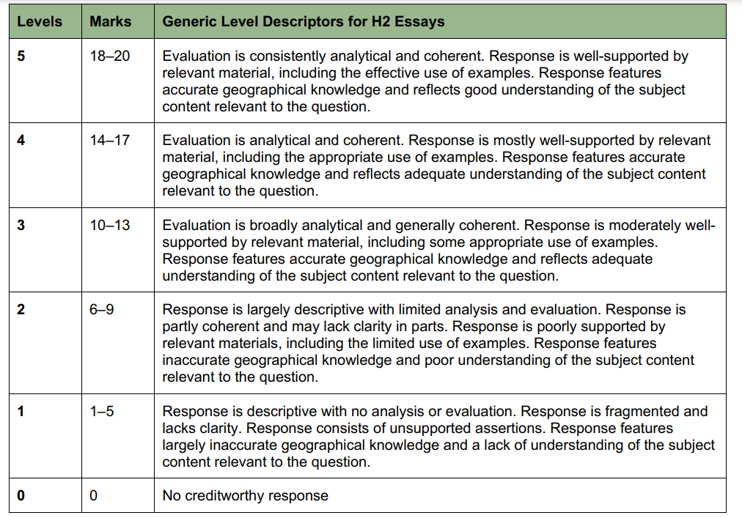

End

